- Gas exchange takes place at the alveoli, describe features of the alveoli which makes it ideal for gas exchange.

- List the reasons to why gas exchange is effective in the lungs.


- Explain the structure of the alveoli

Diffusion takes place at the site of the lungs. Explain the process of diffusion at the sit of the lungs.
(4 marks)
1 mark | Diffusion is when gases move from an area of high concentration to low concentration across a concentration gradient.
1 mark | (In the lungs) the alveoli have a high concentration of oxygen and a low concentration of CO2
1 mark | The bloodstream has a high concentration of CO2 and a low concentration of O2
1 mark | Oxygen will travel across the concentration gradient from the alveoli to the bloodstream and Co2 will travel from the blood to the alveoli

Question 16 (10 marks)
The image below shows gas exchange taking place at the alveoli in the lungs. For this to occur there must be a concentration gradient; a difference in concentration across a membrane. Discuss how gas exchange in the lungs occurs and how the structure of the lungs allows this to take place efficiently.
Description | Marks
During inhalation oxygen enters the alveoli | 1 mark
Venous blood/deoxygenated blood travels through the capillaries that run past the alveoli | 1 mark
The blood flowing past the alveoli is low in oxygen concentration/pressure | 1 mark
Oxygen concentration/pressure inside the alveoli is higher | 1 mark
Gasses move from area of high pressure to area of low pressure | 1 mark
Oxygen diffuses from the alveoli into the blood | 1 mark
The blood flowing past the alveoli is higher in carbon dioxide concentration/pressure than inside the alveoli | 1 mark
Carbon dioxide diffuses from the blood into the alveoli | 1 mark
Diffusion can occur due to the walls of the capillaries and alveoli being only one cell thick | 1 mark
Alveoli are very tiny and provide a large surface area for efficient gas exchange | 1 mark

Mechanics of breathing
INSPIRATION (breathing in)
- Volume of lungs increases
- External intercostal muscles contract & internal intercostal muscles relax to lift rib cage up and the diaphragm contracts to become flatter (this causes a larger volume and thus an area of low pressure)
- Air enters the lungs moving from area of high pressure to low pressure
EXPIRATION (breathing out)
- Volume of lungs decreases
- External intercostal muscles relax and internal intercostal muscles contract to lower rib cage and diaphragm relaxes to become dome shaped (this causes a smaller volume and thus an area of high pressure)
- Air exits the lungs from an area of high pressure to low.

Explain the role that the diaphragm plays during inspiration and expiration
1 mark | During inspiration the diaphragm contracts, flattening and moving downwards.
1 mark | This enables the chest/lungs to expand and inhale air.
1 mark | During expiration the diaphragm relaxes, moving up into a dome shape.
1 mark | This forces air out of the lungs and we breathe out

Carbs and fats are the primary source of fuel for the body during exercise. The type and intensity of exercise will determine which fuel source is used more predominately.
During LOW intensity exercise the body relies on fats as a fuel source. This is because fats are stored in larger amounts in the body and can sustain energy for longer periods of time.
Benefits of fats:
- Hitting the wall… utilising fats allows for glycogen sparing to occur and athletes avoid hitting the wall
- Large fat reserves in the body meaning sustained energy supply
GLYCOGEN SPARING – During exercise the body uses both cabs and fats as energy. By increasing the reliance on fat as a fuel source the body can conserve glycogen stores. Glycogen is a limited resource and once used up fatigue sets in and performance decreases. Glycogen sparing allows for glycogen stores to be maintained for later use in performance.
Downsides to fats:
- Slower release of energy as they require more oxygen to breakdown. (not good for high intensity where quick release of energy required).
- Lower peak performance
- Increase fat consumption means lower glycogen stores

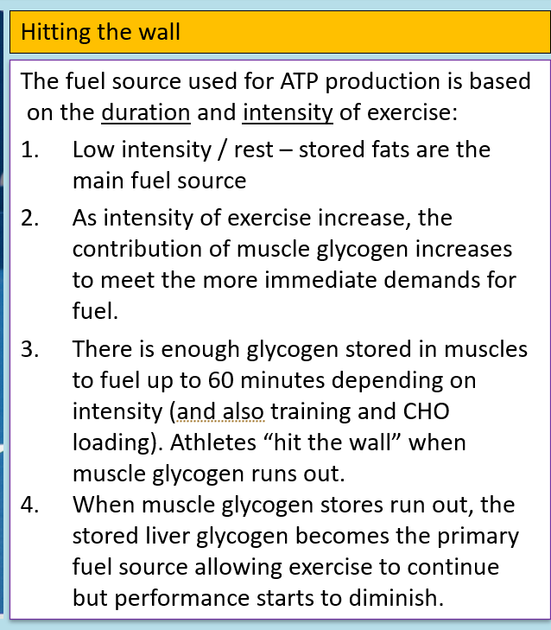

During HIGH intensity exercise the body relies on CARBS as a fuel source.
Benefits of carbs:
- Rapid metabolization meaning high intensity exercise can be performed
- Carbs are stored in the muscles as glycogen so readily available
- Means that fats and especially protein not used as energy
Downsides to fats:
- Limited amount of glycogen can be stored in muscles
- High and Low GI considerations and digestive considerations

Explain the role that carbohydrates, fats and proteins play in an athlete’s diet.
(9 Marks)
Protein
- Approx 15% of an athletes diet
- Growth of muscle tissue
- Repair of muscle tissue
- Production of red blood cells, hormones and antibodies
- Contributes to ATP production when carbohydrate and fats stores are depleted. This may occur in extreme circumstances such as starvation or during ultra endurance events such as the Hawaiian Ironman.
Fats
- Make up 20-30% of an athletes diet
- Fats are the major energy source during rest (60%) & light to moderate exercise but have little input during intense exercise – this is because fats take a longer about of time to break down
- Trained athletes can break down fats faster and therefore do use them as a secondary source of energy when needed
Carbohydrates
- Make up the majority of an athletes diet
- First converted to blood glucose leading to a rise in insulin levels
- Excess blood glucose converted to glycogen
- Glycogen is stored in the muscle and liver for future use
- High, Mid and low GI foods – effect on blood glucose levels

Considering the strenuous requirements of the Tour De France, EXPLAIN what would be your recommendation for a pre-stage meal, nutrition during and nutrition immediately after the race?

Explain how a marathon runner will nutritionally fuel and hydrate themselves prior and during the race to optimise their performance.
3 marks for pre meal  2 for each other macronutrient | Pre  - Think about food preferences and digestibility of food  - Carbohydrate loading the night before each stage - glycogen storage and slower release of energy. Carbohydrate loading strategy to supplement glycogen stores in muscle and liver in the days/week leading into competition to delay glycogen depletion/fatigue.  - 10-12g of carbohydrate per kg of body mass for effective carbohydrate loading to be consumed in the day prior. Pasta, rice, bread etc.  Most efficient energy source to regenerate ATP at sustained higher intensity exercise.  - Hydrate with 1L water, and then another 300ml just before and avoid caffeine as it is a diuretic  - Drink high carb drinks such as Lucozade while carb loading as they are extremely high carb (not suitable for during exercise)  Prior - Low Glycaemic Index Foods  Consume slow-release foods that break down slowly and release energy gradually for sustained energy release. Released into blood stream gradually to raise blood sugar.  Should be consumed as pre-event meal 2-4 hours prior to marathon.  During  - High GI Carbohydrates – keep up the supply of glucose and fast release of energy Should be consumed at intervals during race to delay (top-up) glycogen depletion in muscles and liver such as lollies, sports drinks, energy gels.  - Consume water every 15 - 20 minutes (approx. 200ml) to replace lost fluids  - Also consume other drinks such as sports drinks which contain carbohydrates  After  - High GI foods recommended within 30 minutes of finishing as this is when body is most responsive to topping up glycogen stores  - Consumer lower GI foods later on in the 24 hours post exercise to replace liver glycogen stores  - Consume protein and fats to replenish lost stores, promote muscle recovery and reduce the effects of fatigue and soreness.  Fluids:  - You want to replenish back to pre-exercise weight  - Include electrolytes (sports drinks) to avoid cramping and replenish lost body salts through sweating.  - For every 1L of fluid loss, you must replace with 1.5L as you will urinate some of this out  - Need slightly salty fluid to keep osmolality higher so you don’t urinate as much  - Avoid alcohol and caffeine due to their diuretic effect

